CONCISE NOTE OF LECTURE 2- FUNCTION

Relations vs. Functions

A relation is just a relationship between x- and y-coordinates that means two variables or two equations.

Example 1: y2=x

Example 2: If we consider two set like, A= {1,5} and B={3,4}

Then the product of the two sets are A×B= {(1,3), (1,4) (5,3) (5,4)} and the order should be (x,y). But if we say that x>y then the product answer should be A×B= { (5,3) (5,4)}. So relation depends on the given condition.

In the set of everything that is a relation, there's a smaller subset which we call functions.

A function tries to define these relationships. It tries to give the relationship a mathematical form. An equation is a mathematical way of looking at the relationship between concepts or items. These concepts or items are represented by what are called variables.

Example: y=x+3

A variable represents a concept or an item whose magnitude can be represented by a number, i.e. measured quantitatively. Variables are called variables because they vary, i.e. they can have a variety of values. Thus a variable can be considered as a quantity which assumes a variety of values in a particular problem. Many items in economics can take on different values. Mathematics usually uses letters from the end of the alphabet to represent variables.

Example1: Set variable A={2, 6, 8, 10} so the value of a set is 2 , 6, 8 and 10 which is changeable.

Example2: Equation Variable Y=X+3, Here Y and X is two variable and Y is changeable for the all distinct value of X.

### Domain:

The “domain” of a function or relation is:

* the set of all values for which it can be evaluated
* the set of  allowable “input” values
* the values along the horizontal axis for which a point can be plotted along the vertical axis

### Example 1:

• The set "A" is the Domain,

• The set "B" is the Codomain,

• And the set of elements that get pointed to in B (the actual values produced by the function) are the Range, also called the Image.

And we have:

* Domain: {1, 2, 3, 4}
* Codomain: {1, 2, 3, 4, 5, 6, 7, 8, 9, 10}
* Range: {3, 5, 7, 9} 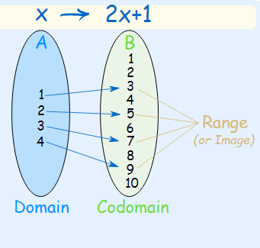

Example 2: a simple function like f(x) = x2 can have the domain (what goes in) of just the counting numbers {1,2,3,...}, and the range will then be the set {1,4,9,...}

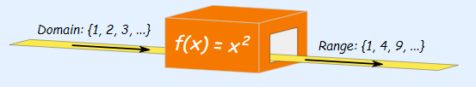

Domain to Range f(x) = x^2

And another function g(x) = x2 can have the domain of integers {...,-3,-2,-1,0,1,2,3,...}, in which case the range is the set {0,1,4,9,...}

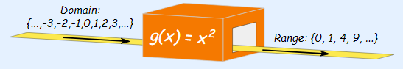

### Range

The “range” of a function or relation is:

* the set of all values that it can produce
* its “output” set of values
* the set of values along the vertical axis for which a point can be plotted on its graph

### Codomain

The “codomain” of a function or relation is a set of values that includes the Range as described above, but may also include additional values beyond those in the range.

Codomains can be useful when:

* You need to restrict the output of a function. For example, by specifying a codomain to be “the set of positive Real numbers”, you are instructing any who use the function to ignore any negative values it produces.
* The Range might be difficult to specify exactly, but a larger set of numbers that includes the entire Range can be specified. For example, a codomain could specify the set of all positive Real numbers, even though the function does not generate all possible positive Real numbers.
* More examples are given below:

Example1:

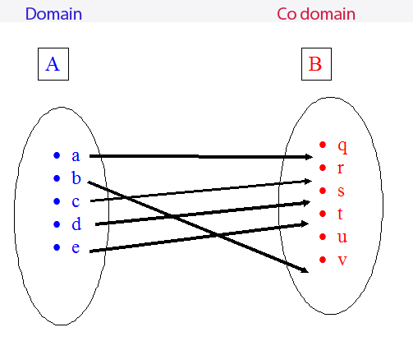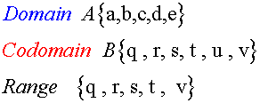

Example:2

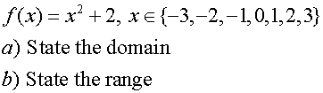

14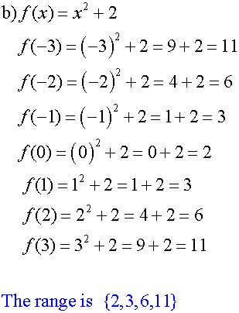

Example 3:

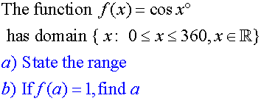

17

Example 4:

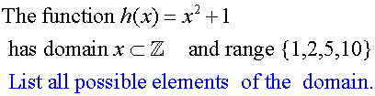

20

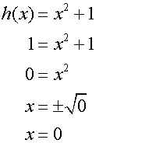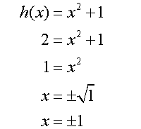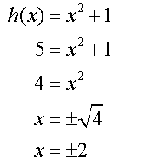

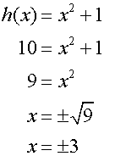25

## How to Find the Domain of a Rational Function: Examples with Solutions

## 

f(x) can take real values if the denominator of f(x) is NOT ZERO because division by zero is not allowed in mathematics  
x - 2 ≠ 0  
Solve the above inequality for http://www.analyzemath.com/DomainRange/domain_rational/x.png?ezimgfmt=rs:10x8/rscb1/ng:webp/ngcb1 to obtain the domain: x ≠ 2  
Which in interval form may be written as follows  
(-∞ , 2) ∪ (2 , +∞)

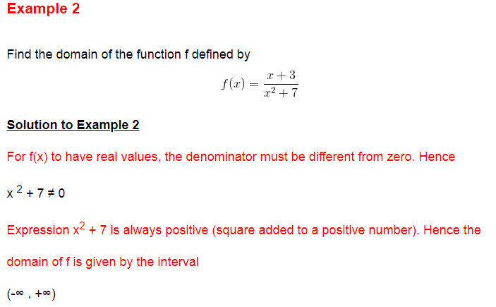

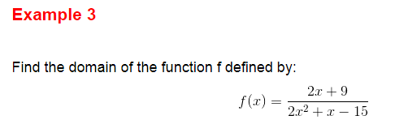

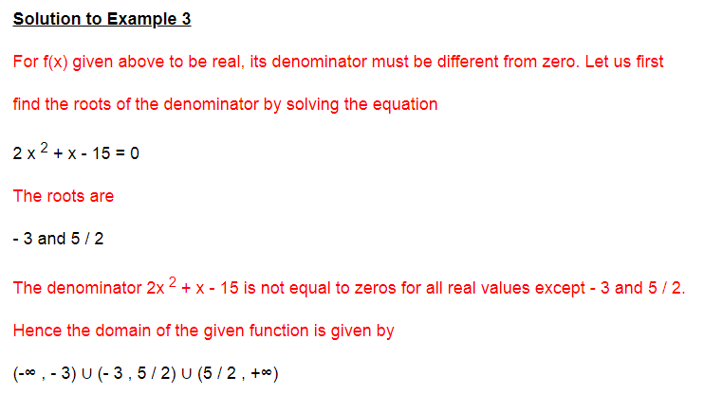

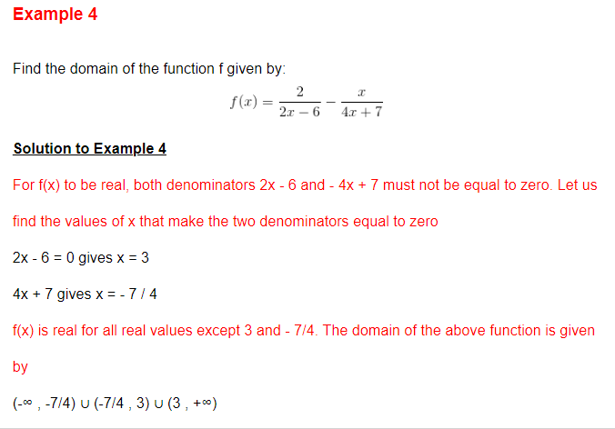

## Examples on How to Find the Domain of Square Root Functions with Solutions

### Example 1

Find the domain of function f defined by

f(x) = √(x - 1)

#### Solution to Example 1

* For f(x) to have real values, the radicand (expression under the radical) of the square root function must be positive or equal to 0. Hence  
  x - 1 ≥ 0
* The solution set to the above inequality is the domain of f(x) and is given by: x ≥ 1  
  or in interval form [1 , +∞)

### Example 2

Find the domain of function f defined by

f(x) = √ [ (x - 2)(x + 3) ]

#### Solution to Example 2

* For f(x) to have real values, the radicand (x - 2)(x + 3) must be positive. Hence  
  (x - 2)(x + 3) ≥ 0
* Solve the above inequality to obtain the solution set, which is also the domain, in interval form as follows:  
  (-∞ , -3] ∪ [2 , + ∞)

### Example 3

Find the domain of function f defined by:

f(x) = √ [ x2 + 2 x - 1 ]

#### Solution to Example 3

* For √ [ x2 + 2 x - 1 ] to be real, the radicand must be positive or equal to 0. Hence the inequality  
  x2 + 2x - 1 ≥ 0
* The solution set of the above inequality, which is also the domain, is given in interval form as follows:  
  (-∞ , -1-√2] ∪ [-1+ √2 , + ∞)
* The domain of the given function is given by the interval (-∞ , -1-√2] ∪ [-1+ √2 , + ∞).

### Example 4

Find the domain of function f defined by:

f(x) = √[ (2x - 1)/(x + 3) ]

#### Solution to Example 4

* The domain of this function is the set of all values of x such that (2x - 1)/(x + 3) ≥ 0 which is an inequality to solve. The solution set of the above inequality which is also the domain is given by  
  (-∞ , -3) U [ 1 / 2 , +∞)

Domain and Range of Logarithmic Functions

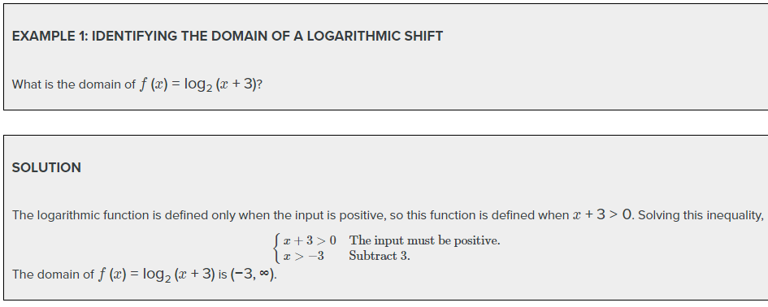

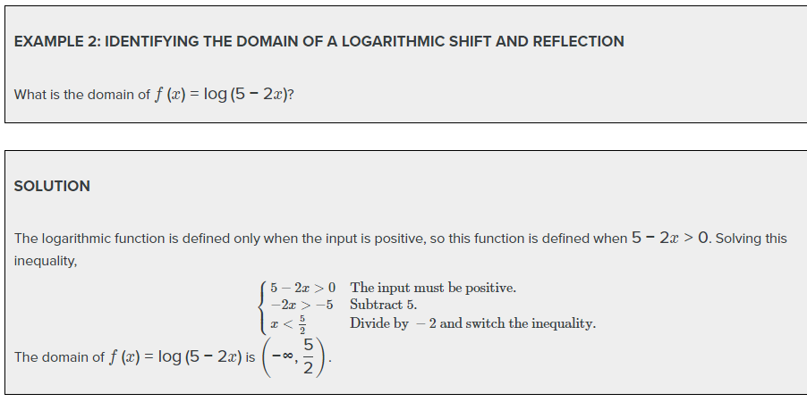

When we call relation as a function?

|  |  |  |
| --- | --- | --- |
| Example 1 | | |
| Problem | Is the relation given by the set of ordered pairs below a function?  {(−3, −6),(−2, −1),(1, 0),(1, 5),(2, 0)} | |
|  | |  |  | | --- | --- | | *x* | *y* | | −3 | −6 | | −2 | −1 | | 1 | 0 | | 1 | 5 | | 2 | 0 | | Organizing the ordered pairs in a table can help.  By definition, the inputs in a function have only one output.    The input 1 has two outputs: 0 and 5. |
| *Answer* | The relation is not a function. |  |

|  |  |  |
| --- | --- | --- |
| Example 2 | | |
| Problem | Is the relation given by the set of ordered pairs below a function?  {(−3, 4),(−2, 4),( −1, 4),(2, 4),(3, 4)} | |
|  | |  |  | | --- | --- | | *x* | *y* | | −3 | 4 | | −2 | 4 | | −1 | 4 | | 2 | 4 | | 3 | 4 | | You could reorganize the information by creating a table. |
|  | Each input has only one output. | Each input has only one output, and the fact that it is the same output (4) does not matter. |
| *Answer* | This relation is a function. |  |

Identify Function from a graph:

The vertical line test can be used to determine whether a graph represents a function. If we can draw any vertical line that intersects a graph more than once, then the graph does *not* define a function because a function has only one output value for each input value.

